Guide to the Basic
Incident Response Plan
Template
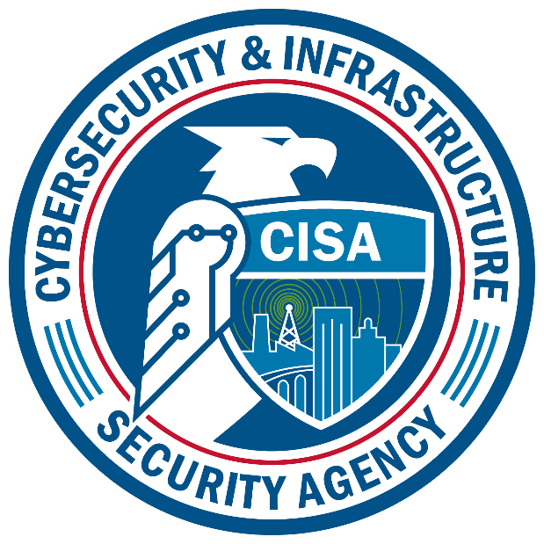

An Incident Response Plan (IRP) is a written document, formally approved by the senior leadership team, that helps your organization before, during, and after a confirmed or suspected security incident. Your IRP will clarify roles and responsibilities and will provide guidance on key activities. It should also include a list of key people who may be needed during a crisis.

This Basic IRP template, which can be found after page 9, was developed to be used for a single incident, for non-Information Technology (IT) staff. It was built based on information in the following publications; CISA’s Federal Government Cybersecurity Incident and Vulnerability Response Playbook, CISA’s Incident Response Plan (IRP) Basics, and NIST SP 800-61r2. It is recommended that you go through this guide and use the Basic IRP template, filling it out and editing as necessary to meet your needs. Once a draft is complete, share it with the appropriate staff to get their feedback and update it accordingly; then have it approved by senior leadership. Once approved it is recommended you print out a copy and store it in a visible binder and then train staff on the template and location(s) of the hard copy and digital copies. Ensure that everyone is using the correct version. On the bottom left of each page in the footer section is a version number, remember to update the version after edits.

When the incident is declared over, the document(s) should be archived according to retention policy, and a new (updated as necessary) template should be printed, or new digital copy used. While this template can be used for a smaller organization, mid-size or larger organizations may want to consider having each department or office have their own shorter version for their specific department/office. Additionally, the Emergency Manager or Continuity Coordinator could have copies for each office or have a prioritized roll up of all.

The Basic IRP is broken into 3 separate sections.
- Key Contacts
- Key Critical Services and their Availability
- Incident Response Report – Non-Technical

When an incident does occur, having Key Contacts upfront, that are up to date, is critical. Faced with a high-pressure situation, the best practice to have an IRP ready to quickly assemble the staff and partners needed to address (detect, analyze, contain, eradicate, and recover) the current incident.

The next section provides your office/department with a listing of Key Critical Services and their Availability. The Key Critical Services should only be services that pertain to your office/department. Consider prioritizing the services according to criticality to your office. In this section there are basic IT network services listed as well. During an incident it’s a good practice to quickly check critical systems availability to help your Key Contacts understand the impact the incident is having to your critical systems which, in turn, can help the Tech Manager or IT Contact determine the potential cause.

The final section is the Incident Response Report. This report is only needed should the Incident Manger (IM) require additional information about the incident. The template can be used to better help the IM, Tech Manager (TM), CM, and possibly others understand the incident and its impacts, while providing the office/department a guideline on what type of information should be passed on. Feel free to fill out report and keep for you own records as necessary. Always get approval from either IM or Communications Manager (CM) should Key Contacts or others request additional information.

Key Contacts Section Details
- Use the digital template to fill out Key Contacts columns for Name, Job Title or Role with IRP, Phone Number(s), and Email sections as it will be easier to read by everyone once the IRP is needed. Edit, add, or remove rows to match your office.
- Recommend to have only one name per row. Do not try to combine multiple staff into one cell as it could make it harder to read during an incident.
- Roles – Incident Manager, Tech Manager, Communications Manager. These roles should be defined, communicated, approved by leadership and users should be properly trained on these roles. Best practice is to define these roles prior to an incident, but they can also be assigned during an incident depending on Key Contacts and staff availability. These roles can be combined with another’s Job Title or Role. For example, the IT Contact may also be the Incident Manager and Tech Manager. Modify, redefine as necessary. Best practice is to only identify one individual for each of these roles. Should you define each role with a staff member prior to any incident, consider adding a backup or deputy for each in case the primary person is unavailable or until they arrive to take over from backup/deputy.
  - Incident Manager (IM) - This person leads the response. They manage communication flows, update stakeholders, and delegate tasks. However, the IM does not perform any technical duties. During a time of crisis, time dilation affects people’s perception of time passing. The IM will monitor the clock to avoid that common problem. The IM should also lead the hotwash meeting (outlined below) to gather lessons learned.
  - Tech Manager (TM) - This person serves as the technical subject matter expert. They will bring in other internal and possibly external technical experts (with the consent of the IM and possibly your attorney!)
  - Communications Manager (CM) - The Communications Manager (CM) will interact with reporters, post updates on social media, and may interact with external stakeholders. This role is also sometimes referred as a Public Information Officer (PIO).
- Red vs Black for Job Title/Role: In the template red font color indicates these are Key Contacts who should be alerted as soon as there is an incident. These contacts are up front and stand out for anyone who opens the IRP. The name and other columns should continue to be black so everyone can read their contact and additional notes.
- Add External dependencies that your department or office relies on as Key Contacts. Add major vendors that you do business with that can affect your offices critical services. Examples could be printer/copier vendor, maintenance staff, application vendor that your office depends on such as Payroll or a Recording application. Do not overdue it here, and create a phone directory. If your office depends on, responsible for, pays for the service, then add to your key contacts. If another department or office is responsible for, manages, pays for the service, consider leaving it off your list. Keep it simple. Discuss and plan further with your Emergency Manager and leadership.

- The Notify column –The intent of this column is that during an incident, this column can be quickly scanned by the Incident Manager for those who are needed to be part of the incident response team and then checking the box indicating to reach out to them. Should a contact always need to be contacted go ahead and check the box up front. DO NOT USE this column to contact everyone on the list. Not all key contacts MUST or should be contacted. Ask yourself – who do I need at this moment to be in contact with to help solve this incident? Those to be contacted are to help solve the incident and minimize any impact – NOT to be used for gossip or simple notification. The Incident Manager or, Communications Manager with IM approval, can update everyone else once more is known and as they can. Many managers and senior leadership feel they must be notified immediately. Formally having this template approved by senior leadership should help minimize unnecessary, time-consuming communication.
- Additional Notes column Use this column for quick notes (example: left VM, no response, wait for approval, on their way). Only use this column as needed. Do not fill out if not required. Consider deleting all comments in the template in the additional note section so when an incident happens the section can be used as intended.
- To add a row for a new contact: Highlight the row you want to duplicate / right click and copy / place the cursor where you want to paste the duplicate row / right click and under Paste Options select “Insert as New Rows”
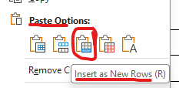
- To delete a row: Highlight the row you want to delete / right click / click the delete button in the smaller menu as shown / click delete row.
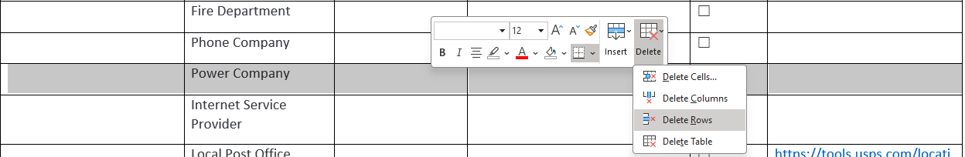
- To update Footer: Double click on the footer and update Version or Confidential marking. The page number should not be edited unless you do not want page numbers. Note this is a 3-column table and each cell is centered. Confidential in red is used for media marking the document as sensitive for distribution and handling Use approved and appropriate marking for your organization.
Key Critical Services and their Availability Section Details
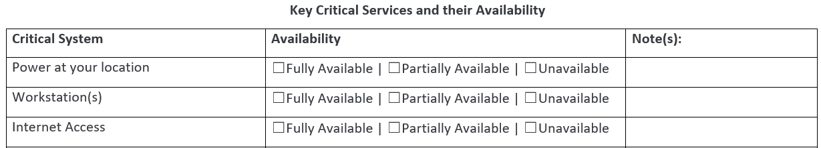

- Edit the Key Critical Services column. See previous section to add or delete a row. The Key Critical Services should only be services that pertain to your office/department.
- Consider prioritizing the services according to criticality to your office.
- For all Key Critical Services listed, all services should have at least one related contact listed in the Key Contacts section. Verify this. Consider training your staff the Key Contacts that support each Service.
- During an incident the office/department can quickly check critical systems availability by checking one of the Availability column boxes (Fully Available, Partially Available, Unavailable), and then add any necessary notes in the Note(s) column. This information can be provided by the Incident Manager, Tech Manager and possibly other Key Contacts to better inform them on the impacts that the incident is having to your office’s/department’s critical systems.
- In this section there are also basic IT services (Internet, Email, phone) listed as well. Consider keeping these to help identify other impacts to IT and communication that can be relayed back to the Incident Manager.
- Should there be an organizational Incident Manager, they may consider adopting a similar Key Critical Services document for each department/office to make requests for certain or all Key Contact departments/office leadership to understand full impacts.

Incident Response Report Section Details
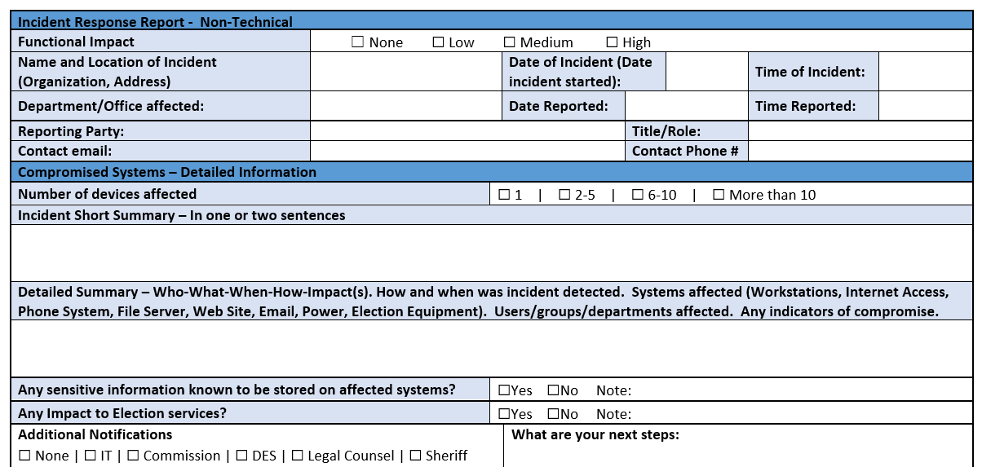

- This report is only needed should the Incident Manger (IM) and Key Contacts (with IM’s approval) require additional information about the incident. When needed, the template can be used to better understand what is known about the incident while providing the office/department a guideline on what type of information should be passed on. The department/office can fill out the IR Report should they feel necessary, but it should not be shared outside their office/department. Only the IM or IM designee (approved in writing or in IRP) should share the IR Report outside the organization.
- The IR report can be written on, or typed in.
- Only fill out applicable white sections of the IR Report. The more sections and detail the better for understanding.
- For the Functional Impact section at the very top, the following definitions apply and are based on NIST 800-61 examples of information impact categories. These can be modified to meet an organization’s Functional Impact terms and definitions. Simply check the box that closely matches the current functional impact of the incident.
  - None - No effect to the organization’s ability to provide services to all users.
  - Low - Minimal effect to the organization. Can still provide all critical services to all users but has lost efficiency.
  - Medium- Organization has lost the ability to provide a critical service to a subset of system users.
  - High - Organization is no longer able to provide some critical services to any users.

Incident Response Plan Change Log Details
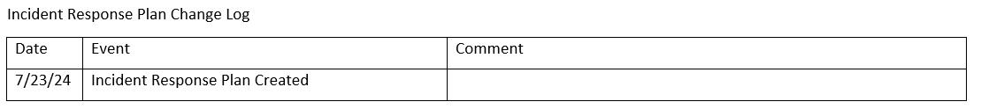

- Change logs can document significant changes since the previous revision.
- Create a new row, and fill in Date, Event or what was changed, and add a comment as needed (for example: add who made the change to the comment box).
- Update the footer section accordingly to indicate there is a new version of the IR Plan to be distributed, communicated and readily available to Key Contacts.

Best Practices - Before a cybersecurity incident

- Review the Incident Response plan at least annually. The best IRPs are living documents that evolve with business changes. Consider creating a reoccurring appointment on a shared calendar to review and update the IR Plan. Consider a period each year where the office has more downtime for the review, for example the 1st week of December. Always ensure during the review that all staff are using and have access to latest version of the IRP.
- Train the staff at least annually. All staff need to understand their role(s) during incident. Consider scheduling the training once the plan has been reviewed and any changes were approved. Train by walking through the IR Plan as a group. Identify who the Incident Manager, Tech Manager and Communication Manager will be as well as who are their backups should they not be available. Consider discussing IM, TM, and CM roles should one or more not be onsite, but the backups are, should the backup assume the Manager role until primary is onsite? Work with Emergency Management to identify the IM, TM and CM and their roles. Discuss and define in the plan each role so everyone knows. Discuss and define in the plan when an incident is declared and by whom. Encourage staff to report possible cyber events to IT or the Managed Service Provider (examples: application or workstation is acting strange or abnormal, phishing email, social engineering call or email). Discuss how staff reports possible cyber events and when these events could become a possible incident (loss of critical service on all workstations, ransomware note(s), phishing email to multiple staff employees, etc.).
- Print the associated incident response plan providing a copy to everyone you expect to play a role in an incident. During an incident, internal email, phones, chat, and document storage services may be unavailable or inaccessible. Print the incident response plan and put it in a designated secure location. Train staff on where it is located. Consider a specific-colored binder that Key Contacts can quickly identify. When the plan is updated, ensure the latest version is printed and put into binder. Ensure old version(s) are properly shredded or archived. Consider a secure online storage and offline storage for digital copies but have to plan to update all locations and communicate to appropriate staff when the plan has been modified or updated. Its critical that everyone be using the same version of the IRP.

- Conduct a tabletop exercise (TTX) at least annually. Sometimes called an attack simulation exercise, a TTX is a role-playing game where a facilitator presents a scenario to the team. The exercise might start with the head of communications receiving an email from a reporter about rumors of a hack. The facilitator will provide other updates during the game to see how everyone plays their role. Every sports team rehearses, and you should too! CISA can conduct TTXs for you or you can use tabletop exercise packages to tailor and develop your own.
- Prepare press responses in advance. For example, should a reporter call your office claiming to know of data stolen from your fileservers, what will you say? Should you be saying anything at all? What about your staff? Who is the Communications Manager or Public Information Officer? If it’s you, having a good “holding statement” will help. For ideas review the “Election Cyber Incident Communications Plan Template – For State and Local officials” created by Harvard Kennedy School Belfer Center and CISA’s Enhancing Election Security Through Public Communications documents.
- Select an outside technical resource/firm that will investigate/mitigate potential compromises in case you need physical hands-on keyboards quickly. If this is not your IT or MSP – add this technical resource to your key contacts list.
- Establish a communications strategy. This includes where to physically meet should communications be impacted or disabled. What are the alternate and approved ways to communicate (example: email, telephone/cellphone/radio, webinar meeting applications like Microsoft Teams). Emergency Managers and Local Law Enforcement should have some good ideas you can use. Consider talking with your Sheriff’s Office about 2-way radio backup communications. Incident Manager, Tech Manager and Communications Manager should work with IT to build email groups or Teams channels for quick alerting, online meetings and updating.
- Know how your critical information assets are backed-up and how long they are retained. Per CISA/MS-ISAC #StopRansomware Guide, it is critical to maintain offline, encrypted backups of data and to regularly test your backups. Backup procedures should be conducted on a regular basis. It is important that backups be maintained offline as many ransomware variants attempt to find and delete any accessible backups. Maintaining offline, current backups is most critical because there is no need to pay a ransom for data that is readily accessible to your organization.
- Review your plan with your attorney, Emergency Manager, local law enforcement agency (LEA), and other important partners. Your attorney and Emergency Manager may instruct you to use a completely different IRP template. Attorneys often have preferences on how to engage with outside incident response vendors, law enforcement, and other stakeholders. In coordination with your attorney, get to know your Sheriff/City police, and your States Fusion Center. Emergency Managers may have a continuity plan that your Incident Response Plan can tie into.
- Meet your CISA regional team. You can find your regional office information here. Within each CISA Region are your local and regional Protective Security Advisors (PSAs), Cybersecurity Advisors (CSAs), Election Security Advisor (ESA), Emergency Communications Division Coordinators, and other CISA personnel to handle a wide array of needs.

Best Practices - During a cybersecurity incident

- Remain calm. Follow the plan, use it as a guide.
- Should Incident Manager, Tech Manager not be available, leave them a short message and continue to contact key staff in particular IT Contact or Emergency Manager.
- Considerations for the Incident Manager (IM):
  - Setup initial meeting with key contacts and Tech Manager.
  - Assess key critical services and their availability to establish full impact of incident and communicate it to Tech Manager.
  - Consider time frame for next or ongoing updates to key required contacts, and all other necessary key contacts until incident is declared over.
  - Consider leveraging a collaborative application (for example Microsoft Teams) that is available to internal staff. The IM or Communications Manager can build a chat group ahead of time or quickly during the incident. These tools can be a great source to document all activities that are taking place and used later for documenting the steps taken during the incident.
  - When there is time, IM or CM should fill out the Incident Response Report to document what is known and update with timestamps as time allows. The Tech Manager can review and edit when they have time (which may be after the incident is declared over by the IM).

Best Practices - After a cybersecurity incident
- Hold a hotwash meeting (sometimes called a “retrospective” or “after actions”). In the retrospective, the IM will report out the known incident timeline and ask for additions and edits. They will then ask for analysis from the incident response team and suggest areas for improvement.
  - Note: the hotwash must be blameless. For a hotwash to have any value, all participants need to feel free to openly discuss the incident in a safe and supportive environment. Security incidents are rarely the result of one person’s action. They are almost always the result of a failure of the overall system. The hotwash will examine people, processes, and technologies. The focus should be on the processes and ways to improve them.
- Review any documents used during the incident including Key Contacts, Key Critical Services, and Incident Response Reports, do not alter the originals but create a final draft with updated and accurate information. Share with Key Contacts or relevant staff and hotwash team members. Archive all documentation used during the incident according to records retention laws or policies.
- Update policies, procedures, IR templates as needed based on the hotwash meeting.
- Communicate the findings to your staff. Transparency builds trust and many staff will appreciate hearing how seriously the executives consider security, which is a major step in building a culture of security.
References for Incident Response
- CISA Incident Response Plan Basics
- Federal Government Cybersecurity Incident and Vulnerability Response Playbooks
- NIST SP 800-61 Rev.2 – Computer Security Incident Handling Guide
- #StopRansomware Guide

Basic Incident Response Plan Template

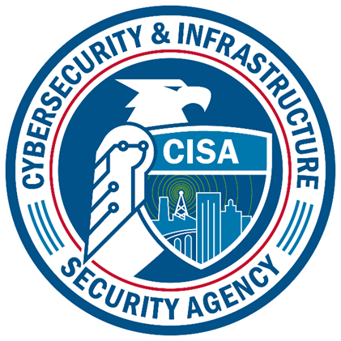

Key Contacts
Name | Job Title/Role | Phone Number(s)  (Office, Cell, Home) | Email  (organizational & personal) | Notify: | Additional Note(s):
 | Incident Manager (IM) |  |  | ☐
 | Tech Manager (TM) |  |  | ☐
 | Communications Manager (CM) |  |  | ☐
 | Superintendent |  |  | ☐
 | Assistant Superintendent |  |  | ☐
 | Technologist 1 |  |  | ☐
 | Technologist 2 |  |  | ☐
 | Emergency Manager |  |  | ☐
 | Principal |  |  | ☐
 | School Safety Coordinator |  |  | ☐
 | Board Member |  |  | ☐
 | Other Key Staff |  |  | ☐
 | Legal Counsel |  |  | ☐
 | Teacher |  |  | ☐
 | Business Manager |  |  | ☐
 | Local Law Enforcement |  |  | ☐
 | Fire Department |  |  | ☐
 | Phone Company |  |  | ☐
 | Power Company |  |  | ☐
 | Internet Service Provider |  |  | ☐
 | Cyber Insurance |  |  | ☐
 | Website Host / Developer |  |  | ☐
Montana Analysis and Technical Information Center (MATIC) |  | 1-406-444-1330 | dojintel@mt.gov | ☐ | State Fusion Center
Montana Disaster and Emergency Services |  | 1-406-324-4777 | mtdes@mt.gov | ☐ | MTDES Website
Montana Information Technology Services Division (SITSD) |  | 1-406-444-2000 | sitsdsupport@mt.gov | ☐ | SITSD Website
Cybersecurity & Infrastructure Security Agency  (CISA) |  | 1-844-Say-CISA 1-844-729-2472 | SayCISA@cisa.gov | ☐ | Report Incident per online form or  Email Report@cisa.gov  For more info – CISA.GOV
Joe Frohlich | CISA -Cyber State Coordinator (CSC) | 1-406-461-2651 | Joseph.Frohlich@cisa.dhs.gov | ☐
Travis Light | CISA -Cybersecurity Advisors (CSA) | 1-406-894-8374 | Travis.Light@cisa.dhs.gov | ☐
Randy Middlebrook | CISA – Protective Security Advisor (PSA) | 1-406-839-1165 | Randy.Middlebrook@cisa.dhs.gov | ☐
Albert Mendoza | CISA – Protective Security Advisor (PSA) | 1-406-371-3585 | ALBERT.MENDOZA@cisa.dhs.gov | ☐
Election Infrastructure Information Sharing and Analysis Center (EI-ISAC) |  | 1-866-787-4722 | soc@cisecurity.org | ☐ | EI-ISAC
Grace Mozingo | EI-ISAC – Senior Regional Engagement Specialist | 1-518-640-3681 | grace.mozingo@cisecurity.org | ☐
FBI Salt Lake City Field Office |  | 1-801-579-1400 |  | ☐

Key Critical Services and Their Availability
Critical System | Availability | Note(s):
Power at your location | ☐Fully Available | ☐Partially Available | ☐Unavailable
Workstation(s) | ☐Fully Available | ☐Partially Available | ☐Unavailable
Internet Access | ☐Fully Available | ☐Partially Available | ☐Unavailable
Email | ☐Fully Available | ☐Partially Available | ☐Unavailable
Access to Critical Work Applications | ☐Fully Available | ☐Partially Available | ☐Unavailable
Access to Work Files | ☐Fully Available | ☐Partially Available | ☐Unavailable
Phone System | ☐Fully Available | ☐Partially Available | ☐Unavailable
Website | ☐Fully Available | ☐Partially Available | ☐Unavailable
Critical Service 1 | ☐Fully Available | ☐Partially Available | ☐Unavailable
Critical Service 2 | ☐Fully Available | ☐Partially Available | ☐Unavailable
Critical Service 3 | ☐Fully Available | ☐Partially Available | ☐Unavailable
Critical Service 4 | ☐Fully Available | ☐Partially Available | ☐Unavailable
Is there Cell Service | ☐Fully Available | ☐Partially Available | ☐Unavailable
Other locations or Offices | ☐Fully Available | ☐Partially Available | ☐Unavailable

Incident Response Report - Non-Technical

Functional Impact |  | ☐ None ☐ Low ☐ Medium ☐ High
Name and Location of Incident (Organization, Address) |  |  |  | Date of Incident (Date incident started): |  |  |  |  | Time of Incident:
Department/Office affected: |  |  |  | Date Reported: |  |  |  |  | Time Reported:
Reporting Party: |  |  |  |  |  |  | Title/Role:
Contact email: |  |  |  |  |  |  | Contact Phone #
Compromised Systems – Detailed Information
Number of devices affected |  |  |  | ☐ 1 | ☐ 2-5 | ☐ 6-10 | ☐ More than 10
Incident Short Summary – In one or two sentences
Detailed Summary – Who-What-When-How-Impact(s). How and when was incident detected. Systems affected (Workstations, Internet Access, Phone System, File Server, Web Site, Email, Power, Election Equipment). Users/groups/departments affected. Any indicators of compromise.
Any sensitive information known to be stored on affected systems? |  |  |  | ☐Yes ☐No Note:
Any Impact to Critical services? |  |  |  | ☐Yes ☐No Note:
Additional Notifications  ☐ None | ☐ IT | ☐ Leadership | ☐ Emergency Manager | ☐ Legal Counsel ☐ Law Enforcement | ☐ Fusion Center | ☐ STATE | ☐ CISA | ☐ MS-ISAC  ☐Other (please specify) |  |  |  |  | What are your next steps:
Is there a need for help or assistance? (From: State, Fusion Center, CISA) |  |  |  | ☐Yes ☐No Note:
Reporting Staff |  |  | Date
Incident Response Plan Change Log
Date | Event | Comment
08/01/24 | Incident Response Plan Created

