School Safety Grant Writing Workshop: Participant Worksheet
Participant Name: ______________________________________________________________ District/School: ________________________________________________________________ Date: _________________________________________________________________________
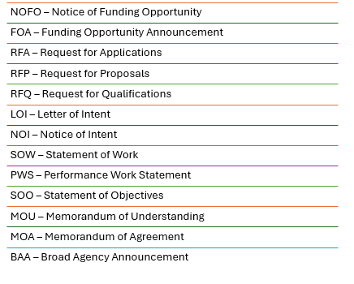
Drafting a Compelling Problem Statement
The 3-Sentence Formula
- Sentence 1: [Target Population] in our community is currently experiencing [Specific Issue].
- Sentence 2: This is evidenced by recent data showing [Insert Metric / Percentage].
- Sentence 3: If left unaddressed without intervention, this will result in [Severe Outcome].
Drafting Space
Sentence 1: __________________________________________________________________________________________
Sentence 2: __________________________________________________________________________________________
Sentence 3: __________________________________________________________________________________________
Data Checklist
- [ ] Discipline Data
- [ ] Bullying Incidents
- [ ] Attendance
- [ ] School Climate Surveys
- [ ] Anonymous Tips
- [ ] Community Feedback

Screening Grant Opportunities for Alignment
Quick Screening Checklist
Requirement | Check
Eligibility | [ ]
Alignment with Need/Priorities | [ ]
Timeline Feasibility | [ ]
Sustainability Plan | [ ]
Non-Supplanting Check: Does this support rather than supplant local funds? | [ ]

Writing Measurable Objectives
SMART Objective Scaffold "By [Date], [Target Group/Site] will [Change/Improve] by [Metric/Percentage] as measured by [Data Source]."
Reference Example: "By June 2027, participating schools will reduce disciplinary referrals for bullying by 15% using our grant funded program."
Drafting Space
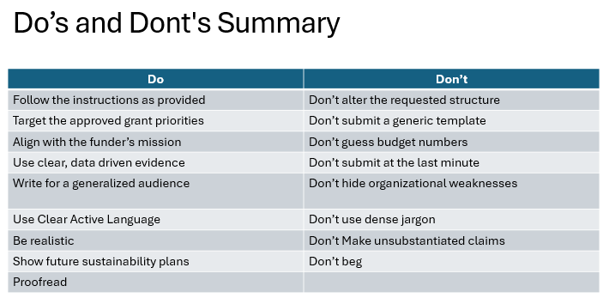
Reviewer’s Scorecard
Review Question | Yes | Needs Work
Is the need clear and supported by data?
Do objectives align with the grant's priorities?
Is the project design realistic?
Does the budget match the project narrative?
Is there a clear plan for sustainability?

Budget planning table
Item | Why is it needed? | How was cost calculated? | Included in narrative? | Allowable?
Personnel |  |  | Yes / No | Yes / No
Benefits / fringe |  |  | Yes / No | Yes / No
Supplies |  |  | Yes / No | Yes / No
Contracted services |  |  | Yes / No | Yes / No
Equipment / software |  |  | Yes / No | Yes / No
Travel / training |  |  | Yes / No | Yes / No
Reviewer lens
The presentation says strong proposals stand out when they align with funding priorities, define the problem clearly, use SMART goals, present a realistic design, show organizational capacity, justify the budget, include evaluation and sustainability, demonstrate collaboration, and follow every compliance requirement.

Reviewer-ready self-check
Rate each area before submission.
Question | Yes | Not yet | Evidence / note
Does the proposal clearly align to the funding priorities?
Is the problem statement specific and supported by data?
Are the goals and objectives clear and measurable?
Is the project design realistic?
Does the application show organizational capacity?
Is the budget justified by the narrative?
Is there a credible evaluation plan?
Is there a sustainability plan?
Are key partners identified?
Did we follow every technical direction exactly?

FINAL RULE: Proofread your proposal and submit before the deadline—never at the last minute!
School Safety Team Contacts: Nevada Department of Education | Office for a Safe and Respectful Learning Environment
- Jeremy Silva, School Safety Team: jeremy.silva@doe.nv.gov
- LaNesha Battle, School Safety Team: lanesha.battle@doe.nv.gov
- Lexi Kovalovich, School Safety Team: lexi.kovalovich@doe.nv.gov

